EXP 07
Strategize impedance matching with characteristic impedance and load impedance through the measurement of
a) Location of the stub
b) Length of the stub
Objective 1 :-
Program code
clc; clear;
ZR = 100; Zo = 600; f = 100*(10^6);
lo = 300/(f*(10^-6));
Ls = (lo/(2*%pi))*atan(sqrt(ZR/Zo));
printf("-Point of attachment = %f cms\n", round(Ls*(10^2)*10)/10);
Lt = (lo/(2*%pi))(%pi + atan(sqrt(ZRZo)/(ZR-Zo)));
printf("-Length of the short circuited stub = %f cms\n", round(Lt*(10^2)));
OUTPUT
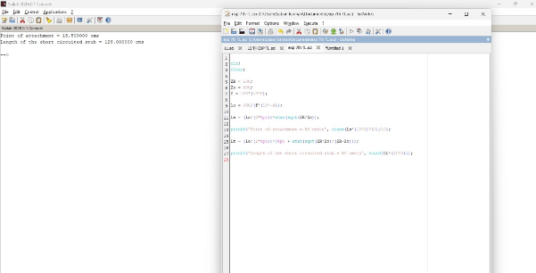
Objective 2 :-
Program code
clc; clear;
ZR = 100; Zo = 600; f = 100*(10^6);
lo = 300/(f*(10^-6));
Ls = (lo/(2*%pi))*atan(sqrt(ZR/Zo));
printf("Point of attachment = %f cms\n", round(Ls*(10^2)*10)/10);
Lt = (lo/(2*%pi))(%pi + atan(sqrt(ZRZo)/(ZR-Zo)));
printf("Length of the short circuited stub = %f cms\n", round(Lt*(10^2)));

Output

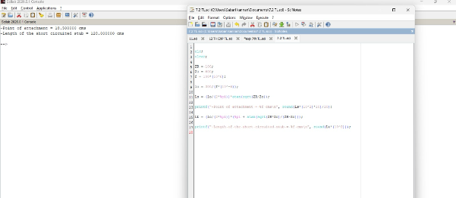

EXP 08
Analysis of Electromagnetic Waves across the two parallel plates by estimating the following
a) Critical Wavelength
b) Guide Wavelength
Objective 1 :-
Program code
clc; clear;
c = 3*(10^8); f = 3000*(10^6);
lo = c/f; l = lo*(10^2); m = 1; n = 0; a = 7.62;
lc = 2*a;
printf("-Critical wavelength = %f cm\n", lc);
lg = sqrt(((lllclc))/((lclc)-(l*l)));
printf("-Guide wavelength = %f cm\n", round(lg*10)/10);

OUTPUT
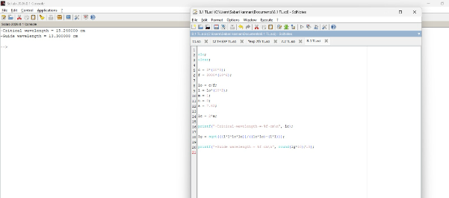
Objective 2 :-
Program Code
clc; clear; close;
// Parallel plate waveguide a = 7.6210^-2; f = 410^9; V = 3*10^8;
m = input("Enter the value of m = ");
fc = (V/(2*3.14))sqrt((m3.14/a)^2);
disp("Cutoff frequency in GHz = "); disp(fc*10^-9);
// Critical wavelength lc = V/fc; disp("Critical wavelength in cm = "); disp(lc*100);
Output



